A Guide to Air Mattress Weight Limits

An air mattress is a mattress that can be inflated with air. It can be used both for sleeping and in the water. They can be stored and carried, and serve multiple purposes. They are ideal for camping and home use.

The sizes are as same as regular mattresses- twin, full, king and queen. Also, you can purchase them in different sizes. There are self-inflatable, or you do it by yourself, form different fabrics (super soft, velvet, rubber, etc.), some have multiple chambers, which can be customized to be more or less firm. The taller the mattress, the more comfortable it is. On the other hand, thinner mattresses are easier to roll up, store and carry.

## Single Air Mattress vs. Double Air Mattress — Does the height of the bed affect the weight limit?

The height of an air mattress somewhat affects the weight limit. Single air mattresses are more suitable for people who are under 300 lbs, but that does not necessarily have to be the case.

The weight limit has more to do with the material and construction of the air mattress, than with the height. There are single air mattresses that are made from firm materials, such as PVC and vinyl, and are heavy duty.

It also depends on the number of sleepers. A single bed carries up to 300 lbs, whereas if two people are sleeping on the same bed, choose a full-size air mattress that can hold between 400 and 500 lbs. there are also mattresses that hold up to 800 lbs.

### Single Air Mattress

A single air mattress has only one chamber and is generally cheaper than a double one. Their thickness is between 4 and 11 inches. This type of bed is suitable for people who do not want to spend a great deal of money, are not going to use it more than a couple of times in a year, it is good for children since they are not so high and they cannot get injured and are perfect for roadtrips. They usually do not come with an electric pump, but this is exactly the reason why they are god for the outdoors.

It is more suitable for people up to 300 lbs, but there also ones that go over that number. You are close to the floor, and if you do not have an air mattress made out of firm material, sagging might occur. The weight limit is lower than the double air mattress because of its height.

### Double Air Mattress (aka Double High Air Mattress)

A double air mattress has usually two or more chambers and can change firmness based on your preference. They are taller, between 18 and 25 inches. They have a real-bed feel and are more comfortable than single air mattresses. You are not close to the floor and getting up is much easier.

They have a higher weight limit than the single air mattresses because of their height, the size and the material that they are made form. Since they are usually made for people with more than 300 lbs, they are supposed to be made out of firm and durable material, which also makes them more durable than the single air mattresses.

As for the purpose of the table, we will use a full size mattress as an example.

|  |  |  |
| --- | --- | --- |
|  | Full Single High Air Mattress | Full Double High Air Mattress |
| Height Range | 4-9 in | 18-25 in |
| Weight Limit Range | Up to 300 lbs | 300-800 lbs |
| Average Price Range | $10-70 | $30-500 |
| Example product from Amazon | [Intex Dura-Beam Standard Single-High Airbed Series](https://www.amazon.com/Intex-64102E-Dura-Beam-Air-Mattress/dp/B0768KS8P7/ref=sr_1_4?dchild=1&keywords=full+size+air+mattress&qid=1625733101&sr=8-4) | [Coleman Air Mattress | Double-High SupportRest Air Bed](https://www.amazon.com/Coleman-2000018352-SupportRest-Double-High-Airbed/dp/B00HN8Y37I/ref=sr_1_3?dchild=1&keywords=full+size+double+air+mattress&qid=1625733482&sr=8-3) |

## How Bed Size Affects Air Mattress Weight Limits

Although it depends on the material whether or not the bed will hold a certain weight, the size of the air mattress also plays a key role.

Putting it simply- the weight limit depends on the number of people who will sleep on the mattress, and therefore on the size. A regular twin air mattress can accommodate up to 300 lbs. This is good for one person. However, if there are two of you and both are of standard weight, then a larger bed would be better. For two people, choose an air mattress with a weight limit between 400 and 500 lbs. For people who are on the heavier side it is better to get a full size mattress, so they have enough room and not to fall off the bed when they move during sleep.

It is easy to conclude that the bigger the size, the bigger the weight limit. A twin size air mattress holds up to 300 lbs for one sleeper, full size 400-450 lbs for one or two sleepers, and a queen size between 500 and 600 lbs for two sleepers.

|  |  |  |  |
| --- | --- | --- | --- |
|  | Twin Air Mattress | Full Air Mattress | Queen Air Mattress |
| Dimensions | 38 x 74 in | 54 x 74 in | 60 x 80 in |
| Weight Limit Range | Up to 300 lbs | 400-450 lbs | 500-600 lbs |
| Ideal for one or two people? | Ideal for one person | For one or two people | Two people |
| Self-inflatable/ air pump | Both | Self-inflatable | Self-inflatable |
| Example Product from Amazon | [Twin Air Mattress with Built in Pump, Inflatable Mattress](https://www.amazon.com/Mattress-Inflatable-Camping-Elevated-Storage/dp/B08SBVYC25/ref=sr_1_10?dchild=1&keywords=twin+air+mattress&qid=1625812035&sr=8-10) | [Full Size Air Mattress for Inflatable](https://www.amazon.com/Full-Size-Air-Mattress-Inflatable/dp/B08PYHNR8P/ref=sr_1_9?dchild=1&keywords=full+air+mattress&qid=1625812107&sr=8-9) | [Intex Queen Dura-Beam Standard Series](https://www.amazon.com/Intex-Dura-Beam-Standard-Essential-Internal/dp/B07F3DSNCB/ref=sr_1_15?dchild=1&keywords=full+air+mattress&qid=1625812107&sr=8-15) |

## What’s The Weight Limit Of A Heavy Duty Air Mattress?

A heavy duty air mattress is a mattress that is made out of tougher material with better seams to support people that weigh over 500 lbs. This also goes for mattresses for two people. What sets them apart from traditional air mattresses is that they are made out of special, thick material that is firm enough to hold up to 800 lbs. they are usually made out of PVC or vinyl. Seam stitching also tends to be better than with the traditional ones. Another critical factor to consider is the height of the mattress. If the mattress is too close to the ground it makes it much harder to get up and on the mattress. The size of the mattress is also very important, especially if you have two overweight people sleeping on it. Make sure to check the width before purchasing it.

Heavy duty mattresses have a higher weight limit since they are specifically made for people who weigh more than 500 lbs, and would not fit and feel comfortable on a traditional air mattress.

|  |  |  |  |
| --- | --- | --- | --- |
|  | Twin Heavy Duty Air Mattress | Full Heavy Duty Air Mattress | Queen Heavy Duty Air Mattress |
| Dimensions | 39 x 75 | 54 x 74 | 60 x 80 |
| Material | PVC, vinyl, virgin vinyl | PVC, vinyl, virgin vinyl | PVC, vinyl, virgin vinyl |
| Weight Limit Range | Up to 800 lbs | Up to 800 lbs | Up to 800 lbs |
| Camping mattress | Good for camping | Slightly too big for camping | Too big for camping |
| Example from Amazon | [Simmons SB9517PLEXPTW Beautyrest Posture-Lux Express Air Bed](https://www.amazon.com/Simmons-SB9517PLEXPTW-Beautyrest-Posture-Lux-Adjustable/dp/B08R6HLZQB/ref=sr_1_9?dchild=1&keywords=twin+heavy+duty+air+mattress&qid=1625926884&sr=8-9) | [Intex Dura-Beam Deluxe Comfort Plush Airbed Series with Internal Pump](https://www.amazon.com/dp/B0869F6XVM/ref=twister_B08CXZ4CYX) | [Coleman Air Mattress](https://www.amazon.com/dp/B00HN8Y37I/ref=as_li_ss_tl?psc=1&pd_rd_i=B00HN8Y37I&pd_rd_w=jsmvO&pf_rd_p=8a8f3917-7900-4ce8-ad90-adf0d53c0985&pd_rd_wg=UYY9E&pf_rd_r=S4A2T5GZNDMWT3PXKTZ6&pd_rd_r=cfa09a03-90e5-11e9-9ae8-ab93d3df4e77&linkCode=sl1&tag=compare4bhp-20&linkId=3af66f45d47978ead455fc6845b074fa) |

## Does The Mattress Construction Affect the Weight Capacity?

Apart from paying attention to the height and weight limit when buying an air mattress, another crucial factors that must be on your check list is the construction of the mattress. The most supportive mattresses have a very good construction so that it does not come to sagging, deflating and seam unstitching. This is especially important for people who are buying a heavy duty air mattress. A good quality mattress will have an internal construction, either built-in air chambers or coils that distribute the air evenly in the bed and therefore provide you with more comfort. Here we will cover air coils, air beams and chambers.

### Air Coils

Air coils are inflatable pillars of the same diameter and are evenly distributed inside the mattress, the more coils there are in the air mattress, the more comfortable it is. To be provided with the most comfort, we advise you to an air mattress that has 30 or more air coils. Their main role is to support your body, stop deflating and sagging, stabilize the bed and give your body support. If they are not evenly distributed, then some parts of the bed will be more sagged and deflated than the others. These coils are filled up with air which makes them stand upright.

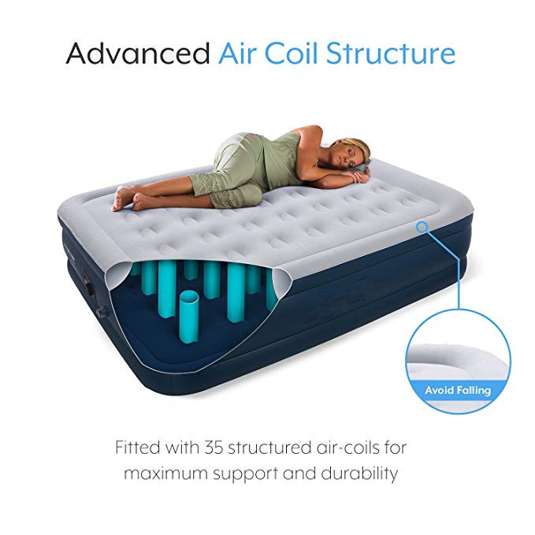

Air beams

Air beams are similar to the air coils. The only difference is that air beams are thin ribs that lie across the mattress in order to enhance the supportive properties. The beams go along the bed and are of the same width. They are all connected so if it comes to deflation it will be evenly spread out.

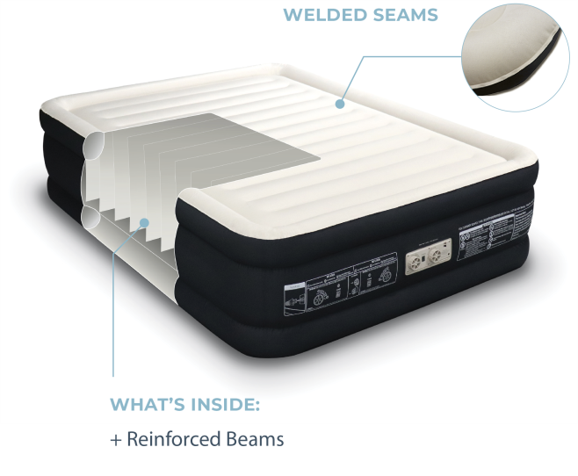

Chambers

There are mattresses that are divided into two indifferent chambers, each having its own valves. It is possible that the chambers have their own air coils and beams to provide extra support and firmness. Their real role is to add a supportive rib in the center of the mattress and therefore allows the weight to be evenly distributed. You will probably have to fold the chambers individually. This is also one of the key differences between a single and a double air mattress. A single one has only one chamber whereas the double one has two or more, and sometimes each one has to be separately inflated.

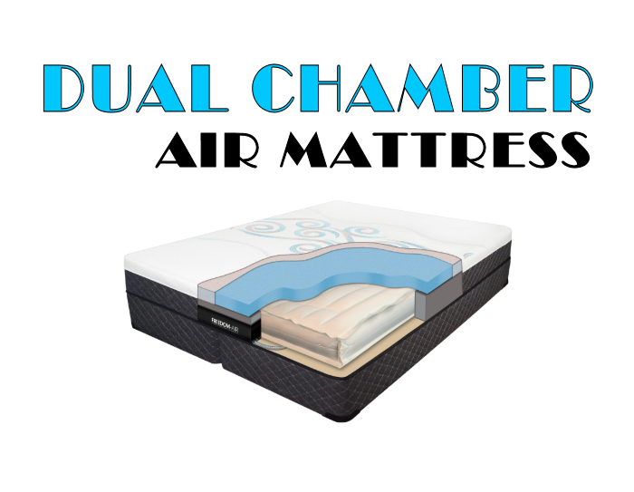

## What Weight Limit Should I Look For When Shopping For A New Air Mattress?

Luckily, there is a wide array of air mattresses to choose from. It really depends on what you are seeking in an air mattress and for what purpose you will going to use it.

For a single person who plans to sleep regularly on the mattress, or to use it for one guest, than a twin size mattress that withholds up to 300 lbs will be just enough. The same goes if you are buying a mattress for camping. There are both single rise and double rise beds that have that kind of weigh limit.

For two people the weight limit of the air mattresses should be from 400 to 500 lbs. That goes for people who are not overweight. For those on the plus size, choose a mattress that holds up at least 400 lbs. If there are two people, than a mattresses between 600 and 800 lbs would ideal for you. These mattresses are usually double high and rarely come as single rise types.

Here is a formula to follow when purchasing an air mattress so you get a mattress that is perfectly suitable for your weight and purpose.

One thing that people usually forget to include when buying an air mattress is the weight of the bedding. The good side is that the bedding does not weigh much at all. A bed setting for a queen size mattress can be maximum 2 lbs. however, if you are going to cover yourself with a thick blanket or quilt, then you better add another 20 lbs at least.

During purchasing, count in the weight of two people and the weight of the bedding including the blanket and quilt, and you will be given your total weight. Make sure that your air mattress at least matches, or preferably exceeds the total weight.

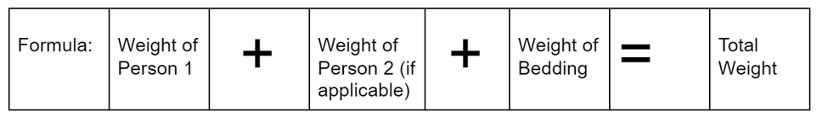

## Do Air Mattresses Need Special Lightweight Bedding?

Depending on the weight limit of the mattress, you can choose bedding on the count of that. Unless you are going to use the bed during colder months, than you can get regular bedding, since the bedding for a queen size mattress is 2 or 3 lbs the most.

Lightweight bedding is made out of linen, cotton or bamboo. Microfiber is also a possibility.

Here is a table that is based on a twin size air mattress.

|  |  |  |  |
| --- | --- | --- | --- |
|  | Normal Bedding Material | Lightweight Bedding | Heavy Bedding Material |
| Dimensions | 39 x 75 | 39 x 75 | 39 X 75 |
| Bedding Material | Cotton, polyester, rayon | Linen, bamboo, cotton | Cotton, wool (for blankets) |
| Weight | 2 lbs | Less than 1 pound | Around 15 lbs |
| Product Example from Amazon | [Utopia Bedding Full Bed Sheets Set](https://www.amazon.com/Utopia-Bedding-Brushed-Microfiber-Resistant/dp/B00NX0WSBI/ref=sr_1_4?dchild=1&keywords=Bedding+full&qid=1625999281&sr=8-4) | [Mellanni Queen Sheet Set](https://www.amazon.com/Mellanni-Bed-Sheet-Set-Hypoallergenic/dp/B00NLLUMOE/ref=sr_1_7?dchild=1&keywords=normal+Bedding+full&qid=1625999344&sr=8-7) | [Bedsure White Full Size Comforter Sets](https://www.amazon.com/Bedsure-Comforter-Full-White-Pieces/dp/B08PBJT5H6/ref=sr_1_4?_encoding=UTF8&c=ts&dchild=1&keywords=Bedding+Comforters+%26+Sets&qid=1625999195&s=bedbath&sr=1-4&ts_id=2224405011) |